Anaerobic Oxidation of a Greenhouse Gas in the
Remnants of Man-Made Toxic Lake

Bryson Mijares - MICR 4321

Project Summary
Methane presents a much larger danger to climate change accounting for roughly 11% of all greenhouse gas emissions in the US.and is 25 times more effective at trapping heat in the atmosphere than CO₂ according to the EPA. While industrial sources of methane may garner much of the attention, freshwater water sources contribute a significant amount to the atmosphere and may be responsible for around 13% of total emissions globally(Martinez-Cruz et al,. 2018). Methane production is often the final step in the decay of organic carbons as a result of bacterial processes in marine and freshwater environments. However, it has been recently observed that Archaea can utilize Anaerobic Oxidation of Methane(AOM) metabolic pathways for energy production. Archaea bacterial species are typically found in extreme environments such as hydrothermal vents and highly toxic briny water systems, such as Owen’s Lake in California. Preliminary data gathered during water testing after lake bed photo development indicates that the surface waters of the lake are nearly depleted of oxygen. Handheld testing equipment has detected dissolved oxygen levels ranging between 0-.6 mg/l, roughly 1/10th the normal level at 40°C with an average pH of 10. Our study seeks to examine the sediments of the lake to determine the presence of Archaea bacteria and if they have the capabilities for the Anaerobic Methane Oxidation.
We will perform this analysis by extracting DNA from previously gathered sediments, using PCR to form amplicons of 16s ribosomal DNA specific to the Archaea domain. As it is highly conserved and can distinguish between Archaea and Bacteria species. We will then use RT-PCR of the pmoA gene to determine whether it is present, as it is a key enzyme in AOM. This data can then be used to determine if the lake is source of methane emissions. Secondly, the data gathered will be made publicly available through our stakeholders, Metabolic Studio who highlights the plight of the area and what further steps can be added to the current remediation efforts. As the lake has become a source of dust storms laden with heavy metals and other toxins after the river feeding it was diverted in the early 1900’s. Additionally, this study is prime opportunity for undergraduate students to obtain real-world lab experience as they will be directly involved in the preparation, execution and analysis of the experiments.

Problem of Significance
Climate change is inevitable whether through man made processes or due the aging of earth. Rivers constantly change their courses due to erosion and seas may become land locked as the earth crust shifts. Other times human activities are responsible for changes in environment, such as the drying up Owen’s Lake. In the early 1900’s water feeding the lake was diverted away to supply the growing urban centers of California. By 1926 the lake was almost completely dry, leaving only highly salty sediment pools behind. Subsequent testing of the muddy waters has shown the presence of heavy metals such as arsenic and high amounts of sulfates(Levy et al,. 1999).
Anaerobic conditions on lake bottoms combined with organic materials often leads to production of methane, highly potent greenhouse gas. However, methane emissions from lakes has been shown to be reduced by the presence of anaerobic bacteria. AOM was first discovered in anaerobic Archaea microbes found in anaerobic marine sediments. Recently, the anaerobic oxidation of methane has been found to occur in freshwater environments as well. Usually in the presence of organic methane source and coupled with sulfates(Martinez-Cruz et al,. 2018). Though the process is not well understood, it is believed to be a large sink of methane reducing the amount released to the atmosphere.(Timmers et al,. 2015) As the lake dried up, aerobic decay of organic materials likely occurred as the section of the lake bed were slowly exposed to the air. Releasing an unknown amount of methane to the atmosphere. To that end, we are wondering if anaerobic archea bacteria can be found in the sediments and do they have the related genes necessary for the anaerobic oxidation of methane? If they are present in the remnants of the lake, then there is a possibility that these bacteria could be a source of alternative method of methane reduction in sulfate rich environments. By transferring their genes into other species of bacteria for bio remediation projects.

Conceptual Model

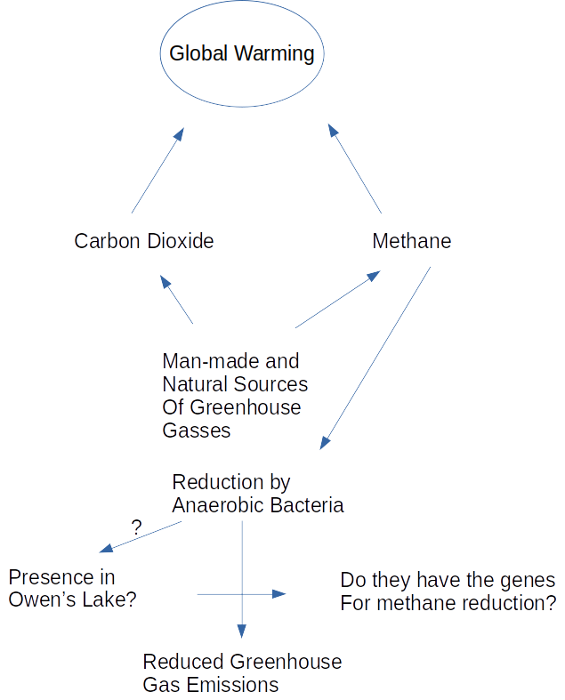

Literature Review
Previous studies have shown that bacterial facilitated methane oxidation can take place in wide variety of environments. From mud volcanoes, brackish waters to marine and freshwater locations. All of which iron or manganese is reduced in the process to generate energy. Other inorganic materials may also be used as long as the chemical reduction potential is energetically favorable. While sulfate reduction has also been described in freshwater, it has usually been in environments with a low concentrations well under 500 μM(Timmers et al,. 2015). Increasing the salinity of the environment along with sulfate concentrations has shown an increase of AOM activity along with reduced methane emissions. As such, AOM is believed to be responsible for reducing around 1/3 of total methane released from freshwater lakes and could responsible for a much larger percentage(Martinez-Cruz et al,l 2018).
Shallow ground water and surface testing of Owen’s lake, California(Levy et al,. 1999) has shown the presence of a significant portion sulfates along with hydrogen sulfide, indicating that there is a high reducing potential in the lakes. Additionally, there is a high amount of variability in the amount of sulfates, ranging from 5% to .4% of the surface salts to the sediments. Iron can also be found in the same regions with slightly decreasing amounts as the sediment depth increases. These results are likely due to the evaporation of the lake waters, leading to the formation of waters with high alkalinity and high brine contents. These conditions are ideal for a multitude of species of halophilic Archaea bacteria to exist. Studies have been conducted in the past on the bacterial composition of the lake sediments, however they are few and far between with several species of anaerobic bacteria being identified in the sediments(Huang et al,. 1998)(Pikuta et al,. 2006)(Pikuta et al,. 2009). However none of these studies have attempted to identify capabilities for AOM. Rather the studies have been expeditions for characterization and discovery of novel species. In other words, there exists a lack of information about the microbiome composition of the lake and our study seeks to expand the current knowledge base.
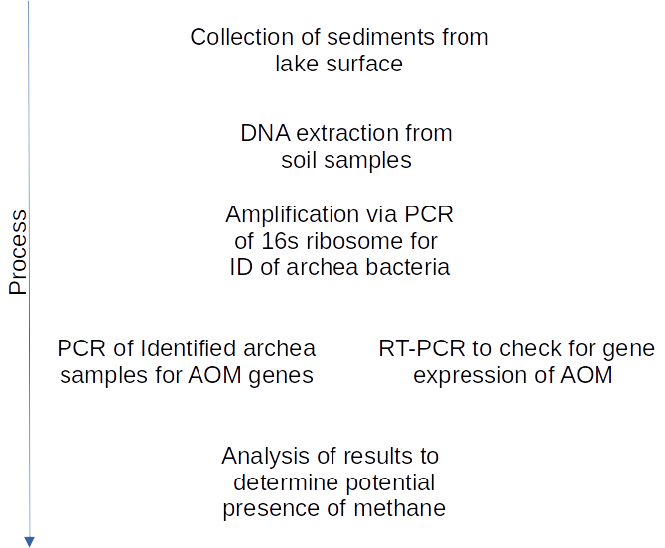

Objectives
To determine if Archaea species can be found in the sediments of the lake and determine if AOM genes are being expressed. If genes are being expressed, then it is highly likely that methane is actively being produced in the lake.

Aims:
1. To extract and amplify microbial DNA from soil samples gathered from lake water photo development sites
2. PCR using genes identified in methane oxidation and 16s ribosomal RNA for ID of methane oxidizing microbes.
3. Determine if the lake is a source of methane emissions.

Hypothesis:
Based upon previous findings we hypothesize that Archaea bacteria are present in the soils. Second, at least one of the species present have the genes for methane oxidation and genes related to AOM are being expressed resulting in the reduction of methane gas released into the atmosphere. Third, methanogenesis is occurring in the sediments of the lake.

Research Plan
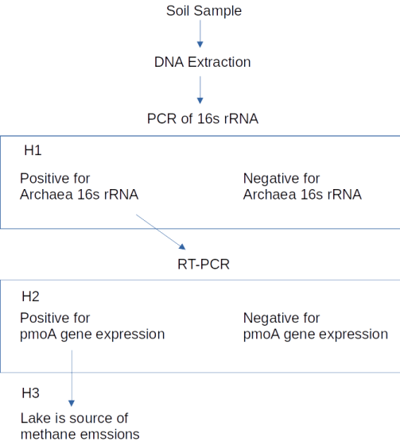

Methods and Materials
-Sediment Samples were collected and stored in whirlpacks from lake bed photo development sites using a ethanol sterilized trowel, flame sterilization was not possible to due to high winds and subsequently frozen at -80°C.
-Extraction of DNA from core sample of the soil using E.Z.N.A Soil DNA kit following manufactures instuctions. Followed by verification of DNA extraction using NanoDrop to determine concentration of DNA.
-Custom design of PCR primers will be completed using ID’d 16s ribosomal RNA sequences from known Archaea DNA sequences. Additionally RT-PCR primers for the pmoA will be designed using published genome sequences from Genbank.
-PCR to be completed using in a 25 or 50 µl reaction depending on DNA concentration from extraction using GoTaq Green master mix following ProGen manufactures instructions. Followed by Electrophoresis in 1% agarose gel in TAE buffer solution.
-RT-PCR will be completed using a Qiagen one-step RT-PCR kit per manufactures instructions. Followed by gel electrophoresis using a 1% gel to separate the products. Primers for RT-PCR are still in the design process.

Justification of Methods
PCR followed by electrophoresis is a standard and highly accepted method for the study of genes and is a common practice to identify the presence specific genes of interest. RT-PCR is being used to determine the presence of the pmoA gene expression and will be used identify if methane is present in the sediments, as it can be used as a source of energy through AOM. A one-step method will be the preferred protocol as mRNA is highly unstable, degrades easily and two-step methods of RT-PCR are prone to contamination. Additionally, to quantify the levels of expression would require the use of RNAseq methods followed by computational analysis. Both of which are currently beyond the scope of this project.

Expected results for each sample:
 | 16s DNA PCR positive | 16s DNA PCR negative
RT-PCR AOM positive | Archaea species with AOM related genes expressed | Other bacterial species with AOM related gene expressed
RT-PCR AOM Negative | Archaea species without AOM related genes expressed | Archaea not present and no AOM related genes expressed

Projected Timeline:
- Week 0
  - Gather soil samples
  - Build PCR primers
- Week 1-2
  - Order PCR Primers
  - Extraction of DNA from soil samples
  - Fine tuning of PCR protocol
- Week 3-4
  - PCR and RT-PCR of samples
- Week 5- end of semester
  - Continued RT-PCR of samples
  - Analysis of obtained results

References:

Huang, C.-Y., Patel, B. K., Mah, R. A., & Baresi, L. (1998). Caldicellulosiruptor owensensis sp. Nov., an anaerobic, extremely thermophilic, xylanolytic bacterium. International Journal of Systematic Bacteriology, 48(1), 91–97. https://doi.org/10.1099/00207713-48-1-91
Levy, D. B., Schramke, J. A., Esposito, K. J., Erickson, T. A., & Moore, J. C. (1999). The shallow ground water chemistry of arsenic, fluorine, and major elements: Eastern Owens Lake, California. Applied Geochemistry, 14(1), 53–65. https://doi.org/10.1016/s0883-2927(98)00038-9
Martinez-Cruz, K., Sepulveda-Jauregui, A., Casper, P., Anthony, K. W., Smemo, K. A., & Thalasso, F. (2018). Ubiquitous and significant anaerobic oxidation of methane in freshwater lake sediments. Water Research, 144, 332–340. https://doi.org/10.1016/j.watres.2018.07.053
Pikuta, E. V., Hoover, R. B., Bej, A. K., Marsic, D., Whitman, W. B., & Krader, P. (2009). Spirochaeta dissipatitropha sp. nov., an alkaliphilic, obligately anaerobic bacterium, and emended description of the genus Spirochaeta Ehrenberg 1835. INTERNATIONAL JOURNAL OF SYSTEMATIC AND EVOLUTIONARY MICROBIOLOGY, 59(7), 1798–1804. https://doi.org/10.1099/ijs.0.016733-0
Pikuta, E. V., Itoh, T., Krader, P., Tang, J., Whitman, W. B., & Hoover, R. B. (2006). Anaerovirgula multivorans gen. nov., sp. nov., a novel spore-forming, alkaliphilic anaerobe isolated from Owens Lake, California, USA. International Journal of Systematic and Evolutionary Microbiology, 56(11), 2623–2629. https://doi.org/10.1099/ijs.0.64198-0
Timmers, P. H. A., Suarez-Zuluaga, D. A., van Rossem, M., Diender, M., Stams, A. J. M., & Plugge, C. M. (2015). Anaerobic oxidation of methane associated with sulfate reduction in a natural freshwater gas source. The ISME Journal, 10(6), 1400–1412. https://doi.org/10.1038/ismej.2015.213

